**Project Log**

**October 30th ,2024**

**Problem Statement 9:**

Scenario: The shift toward digital learning has opened up new opportunities for students but has also introduced significant challenges. Many students struggle with staying organized, motivated, and engaged in their studies when they lack the structure of a traditional classroom environment. Managing multiple assignments, keeping track of deadlines, and finding reliable study resources can be overwhelming, particularly for students who are not accustomed to self-directed learning. Additionally, the absence of in-person interactions with teachers and peers can lead to feelings of isolation, further diminishing students' motivation and performance. While learning management systems (LMS) provide a basic framework for digital education, they often lack the personalization and support needed to address these individual challenges.

**Team Members:**

|  |  |  |  |
| --- | --- | --- | --- |
| **Group** | **Learner 1** | **Learner 2** | **Capstone Project Number** |
| 9 | Swethaa S P | Kshitij Dnyaneshwar Lavhe | 9 |

**Nov 1st ,2024**

**Agenda:**

**1. Introduction**

* Brief overview of the project
* Importance of addressing challenges in digital learning

**2. Project Goals**

* Enhance organization, motivation, and engagement for online learners
* Empower students to take control of their learning journey

**3. Technology Stack**

* **Frontend: Angular**
  + Overview of Angular and its advantages for user interfaces
* **Backend: ASP.NET Core Web API**
  + Explanation of how the backend manages data and business logic
* **Database: SQL Server**
  + Discussion on data management and storage
* **Cloud Deployment: Azure**
  + Benefits of using Azure for scalability and reliability

**4. APIs Overview**

* **Authentication**
  + Secure user registration and login processes
* **Services and Database Integration**
  + Data retrieval and submission services
* **Free APIs for Additional Resources**
  + Accessing educational tools and resources to enhance user experience

**5. Key Features**

* **Note-Taking System**
  + Functionality and importance for student success
* **Assignment Management**
  + Tracking assignments, deadlines, and progress
* **Session Tracking**
  + Organizing and accessing lecture materials and discussions
* **Streaks Feature**
  + Motivation through tracking timely submissions
  + Explanation of how streaks will work
* **Leaderboard**
  + Encouraging competition and recognition among students

**6. User Interface Design**

* Overview of the homepage and navigation bar
* Discussion on user experience and accessibility

**Discussions:**

The transition to digital learning has become increasingly prevalent, and while it offers flexibility and accessibility, it also introduces significant challenges that can hinder student success. Many students find it difficult to adapt to self-directed learning, often struggling with organization, motivation, and engagement. In response to these challenges, our project seeks to provide a robust solution through a web-based application designed specifically for online learners.

Our application will be built using ASP.NET Core Web API, Angular, SQL Server, and Azure cloud, allowing for a seamless user experience and efficient data management. The use of APIs will facilitate secure authentication, enabling users to register and log in securely, and provide essential services for data retrieval and submission. The API architecture will also support the integration of free APIs, allowing access to additional educational resources and tools, thus enhancing the overall user experience. By leveraging these technologies, we can create a responsive and user-friendly platform that caters to the unique needs of students navigating online education.

One of the core features of our application is the note-taking system. Effective note-taking is a critical skill for academic success, particularly in an online environment where lectures may be pre-recorded or presented asynchronously. Our note feature allows students to create, edit, and organize notes efficiently. Each note will include an ID number, date, title, description, and additional resources such as links and files. This structure not only helps students stay organized but also encourages them to engage more deeply with the material by allowing them to compile relevant information in one accessible location.

Another vital component is the assignment management feature. Students often struggle to keep track of various assignments, deadlines, and progress, which can lead to increased stress and a sense of overwhelm. Our assignment feature addresses this by providing fields for the topic name, tags, date assigned, deadline, and progress tracking. Students can categorize their assignments based on urgency or subject matter, enabling them to prioritize their tasks effectively. The progress percentage indicator allows for self-monitoring, helping students maintain accountability and motivation throughout the completion of their assignments.

In addition to notes and assignments, the application includes a session tracking feature. Online learning often involves a series of sessions, whether they are live lectures, recorded classes, or discussion forums. Each session will have a dedicated entry, complete with session ID, date, title, description, and related resources. This organization fosters a sense of continuity and connection among students, making it easier for them to keep up with their studies and collaborate with peers on assignments.

Moreover, the application's user interface will feature a homepage with a navigation bar displaying key elements such as sessions, assignments, notes, streaks, and logout options. This design aims to create an intuitive user experience, reducing the cognitive load associated with navigating multiple platforms and resources. By centralizing these functions, we hope to create a more cohesive and engaging online learning environment.

An important addition to the application is the streaks feature, which will help motivate students by tracking their progress in completing assignments on time. When a student submits an assignment within the deadline, their streak will increase, promoting a sense of accomplishment and encouraging consistent engagement with their studies. This feature aims to foster a habit of timely submissions, ultimately leading to better academic performance. Additionally, we will include a leaderboard that displays the top performers based on their streaks, further motivating students through friendly competition and recognition.

In summary, this project seeks to mitigate the challenges of digital learning by providing a comprehensive application that enhances organization, motivation, and engagement. By focusing on features like note-taking, assignment management, session tracking, streaks, and a leaderboard, alongside robust APIs for authentication and services, we aim to empower students to take control of their learning journey, reduce feelings of isolation, and ultimately achieve greater academic success. As we move forward with development, we are committed to gathering feedback from users to ensure that our application meets their needs and adapts to the evolving landscape of online education.

**Abstract**

The shift to digital learning has transformed educational landscapes, presenting both opportunities and challenges for students. This project aims to address the difficulties associated with online learning, particularly in organization, motivation, and engagement. Utilizing ASP.NET Core Web API, Angular, SQL Server and Azure cloud we will develop a comprehensive application that offers features tailored to enhance the digital learning experience. Key components include a note-taking system, an assignment management feature, and session tracking. These functionalities will help students maintain organization and foster a sense of community, addressing feelings of isolation often encountered in online environments. By implementing a user-friendly interface and personalized support, this project strives to create a digital learning platform that not only meets educational needs but also encourages student engagement and success.

**Preparing Documentation**

Prepare Prototype

**Nov 4th ,2024**

## APIs Overview

### Assignment API

* **Task Management**
  + Create, retrieve, update, and delete assignments to streamline the workflow for both students and educators.

### Note Making API

* **Note Organization**
  + Enable users to create, edit, and manage notes, supporting rich text formatting and tagging for enhanced organization and retrieval.

### Streaks and Leaderboard API

* **User Engagement Tracking**
  + Track user activity streaks and maintain a leaderboard to foster motivation and friendly competition among users based on their performance metrics.

### Free API

* **Public Resource Access**
  + Provide access to a variety of educational tools and resources without authentication, enhancing the overall user experience and engagement with the platform.

**Microservices Application Flow**

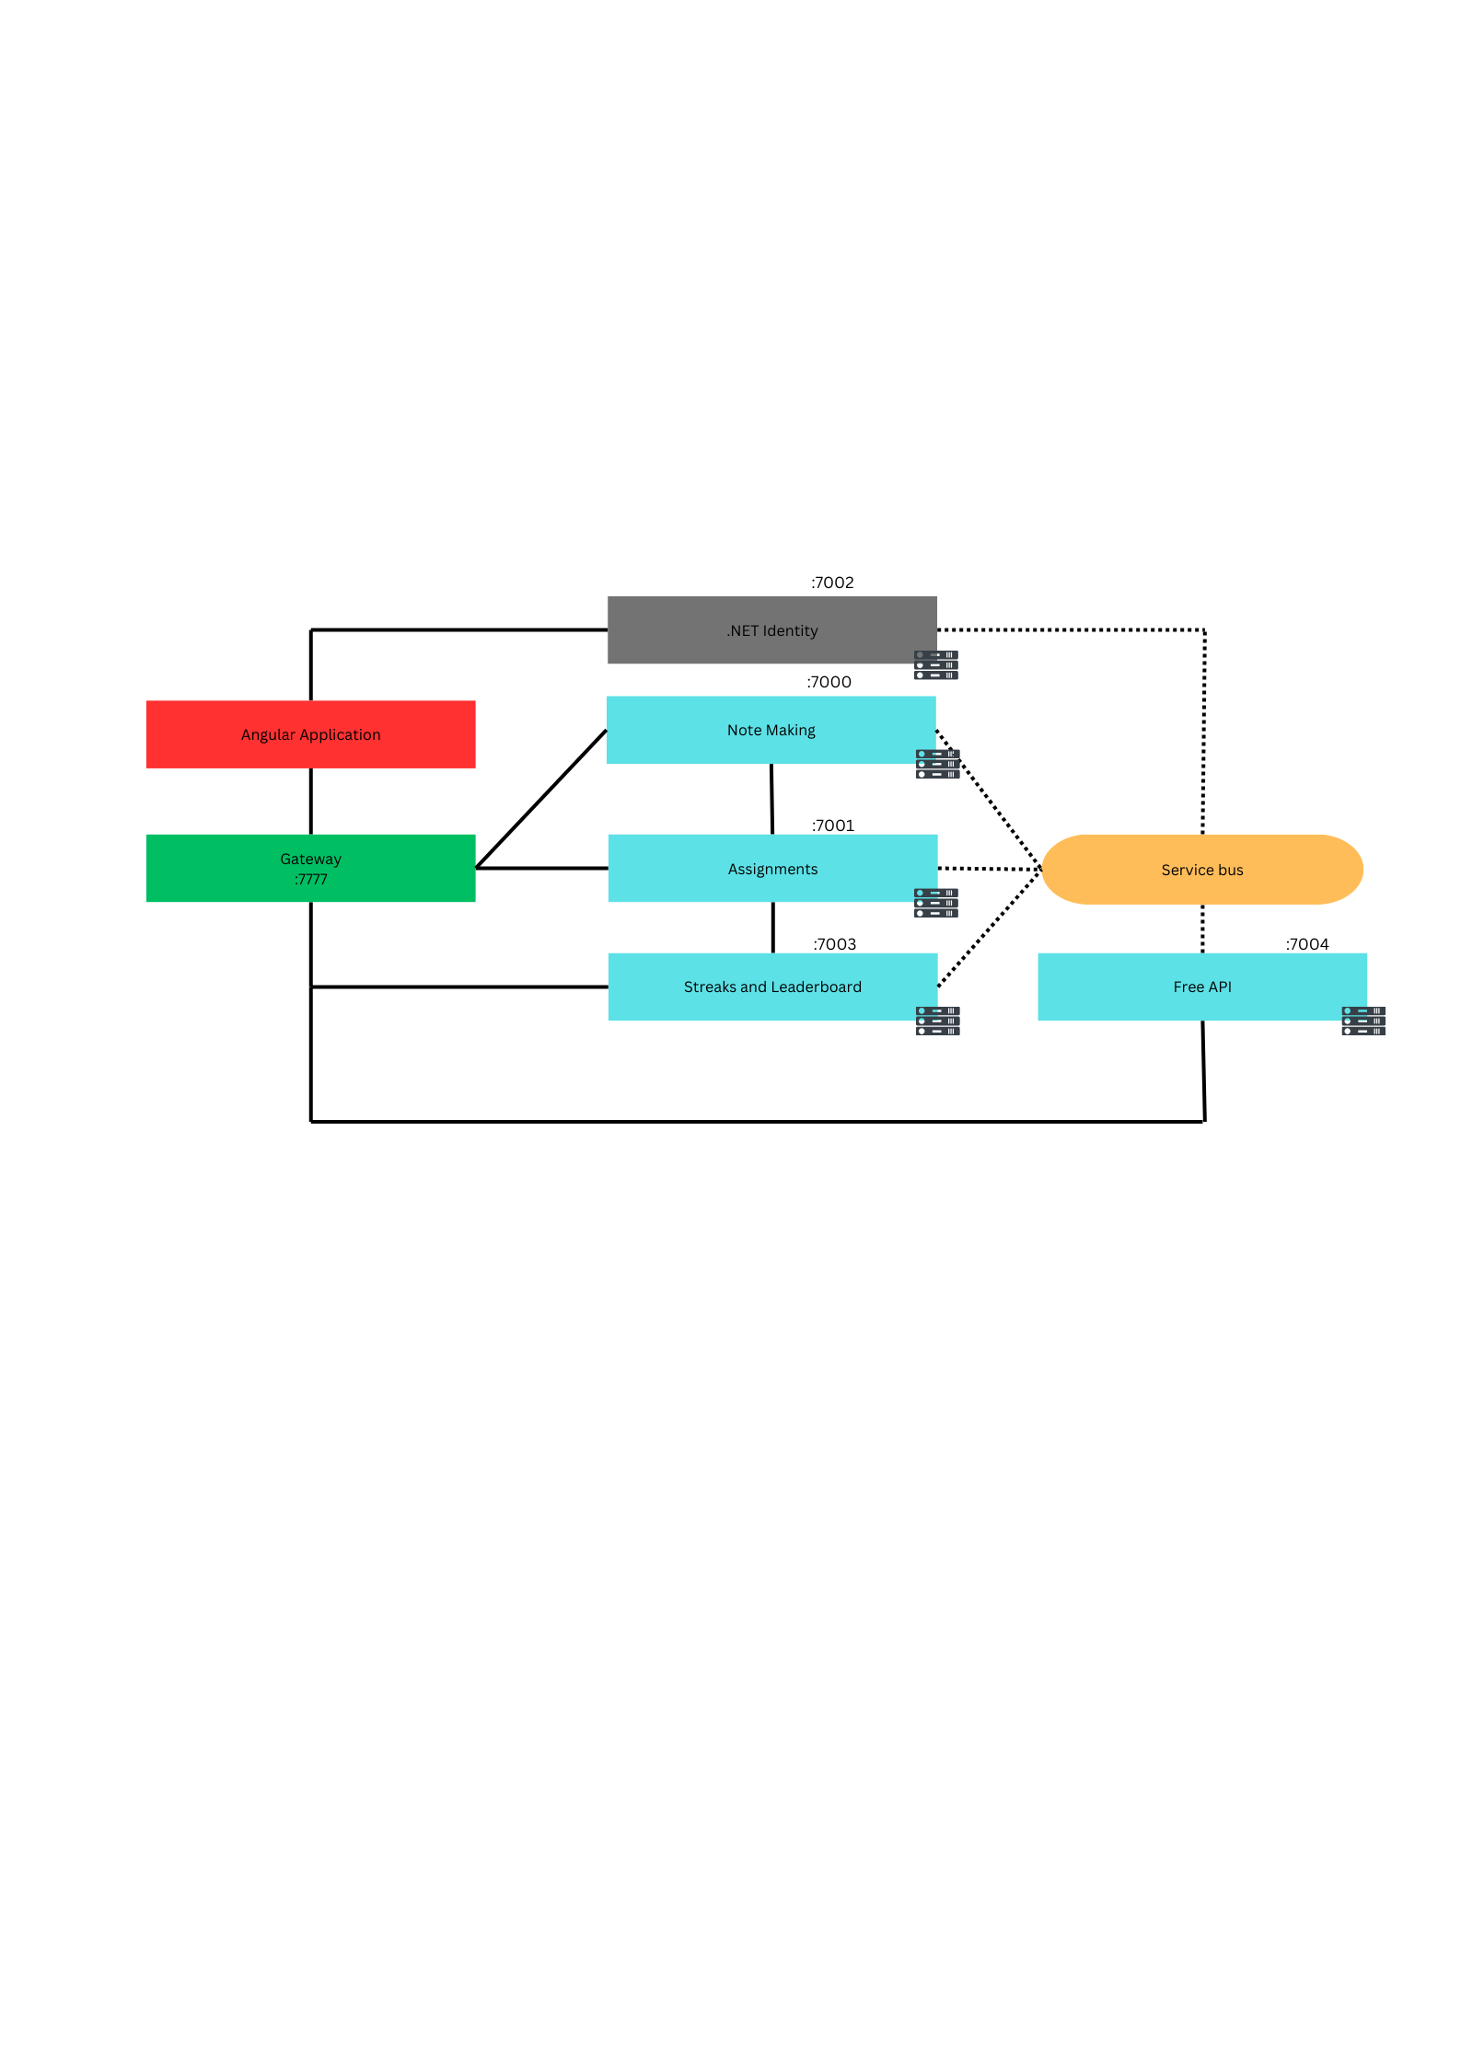

**Nov 5th ,2024**

**Class Diagram:**

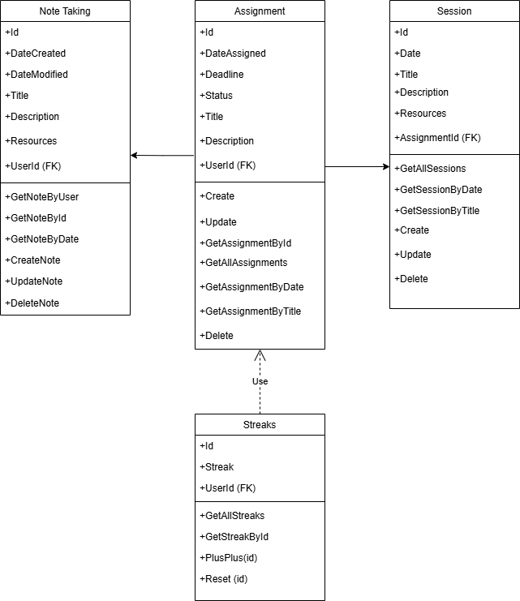

**Nov 6th,2024**

**Modified Class Diagram**

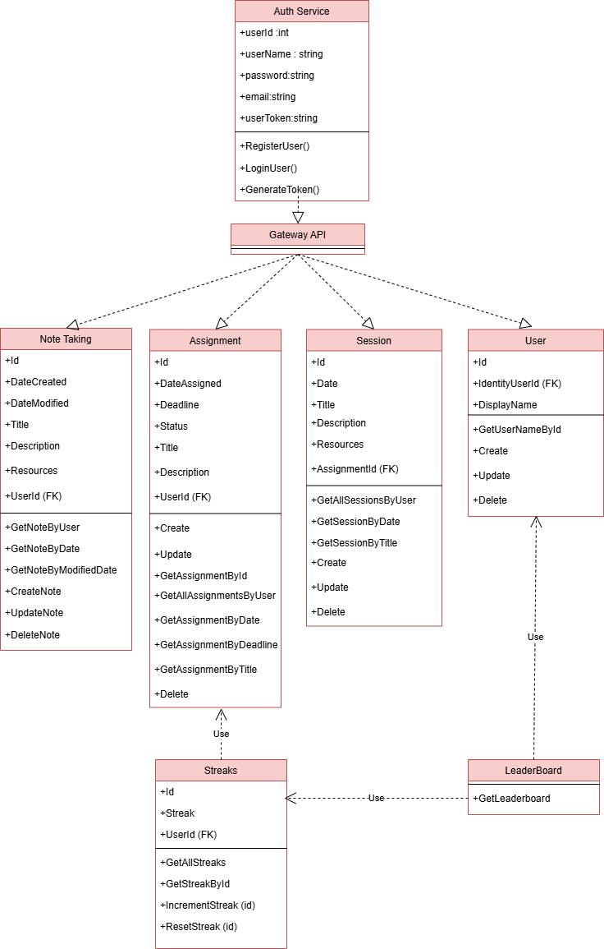

**Nov 7th,2024**

**UI Diagram**

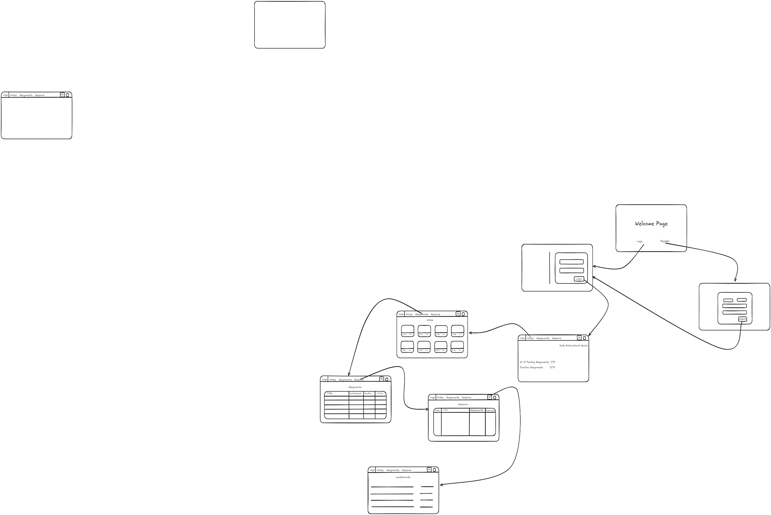

**Nov 8th,2024**